# User Guide of Cocry-pred

The initial interactive interface of Cocry-pred is shown below; click the "Let's get started" button to enter the working interface. Users need to locate GUI.exe under the Software folder and double-click to run the software. Cocry-pred does not require registration or login, and there are no limitations on usage. It is a simple and efficient standalone software. Users can also directly use the provided GUI.py to add and modify software features. The interface upon entering is shown in Figure 1.



Figure 1. The initial interface of Cocry-pred

# Software Usage

The working interface is shown below, followed by specific steps:

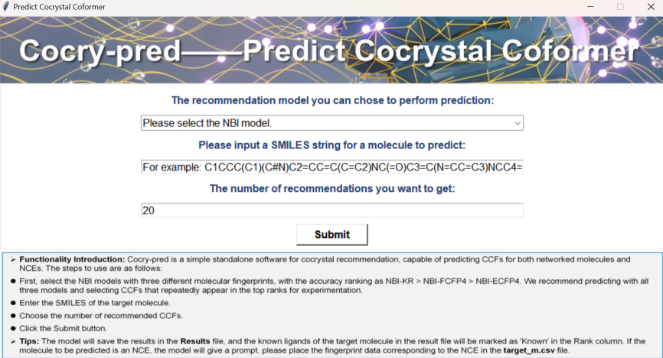

Figure 2. The interface of function

* **Model Selection:** We provide the three best fingerprint network models mentioned in the paper, which are NBI-KR, NBI-FCFP4, and NBI-ECFP4. The precision of the three models is calculated as NBI-KR > NBI-FCFP4 > NBI-ECFP4. However, we recommend that users employ all three models and then focus on verifying the CCFs that appear repeatedly across the three models.
* **Enter the SMILES:** Enter the SMILES of the molecule to be predicted.
* **Enter the number:** Enter the number of CCFs needed.
* **Submit:** Click the Run button, and the results will be saved in the Results folder.
* **Tip1:** Since the KR fingerprint is generated using the PaDEL software, for the cocrystal prediction of NCEs, you need to use PaDEL to calculate the molecular fingerprint of the target molecule, and then copy the molecular fingerprint to the Target_m.csv file in the Data folder to complete the prediction for NCEs.
* **Tip2:** In the Excel result file, all known CCFs of the target molecule are marked as 'Known' in the Rank column.